Analysis on Cigarettes sales in Royal Seven

By: Samriddh Gupta

Introduction

The latest job which I did as the cashier at royal seven have taught me many things. I had been interacting with all kinds of people who comes from all walks of life and from every corner of the country and they have a unique way of interaction and a unique personality. Dealing with people who have different personalities have indeed been helpful for me, but I always wanted to do something more related to my field. As an aspirant Data Analysist, I started looking for a project which could be both helpful for me and the company. I noticed that our store was the only one in town which sells Marlboro Cigarettes at a discount if they were willing to buy 2 of them. This ignite a curiosity in me to find whether the store discount really being utilize or was it in vain. To find more about it, I conducted an experiment which can be used to gather the data and while conducting it, I also added some marketing strategies which I think could be of benefit in increasing the sales production for all the items in the store.

Data Collection

The data was collected and filled by me after a person bought a cigarette. The survey asked some of the basic questions which captures whether the person is buying a Marlboro Cigarettes or not; how many cigarettes they are buying; did they know about the discounts; and what were there emotional condition when they bought it. For the emotional condition, I only tested their facial expression they make while buying the stuff or the way they talk. Most of them does not have any noticeable change in expression and were considered neutral to avoid any misassumptions. The survey was conducted by me for 2 weeks and during my shift in the store. Now the data which I collect for emotion analysis was what I visually see how people were when they bought the cigarettes. I am by no means an expert of Human Emotion Analysis but can make out when people are happy or sad, they are while purchasing a particular commodity. Those are the results which are capture here could vary from person to person as none cannot determine the emotions of a particular person like what they are thinking while I was collecting me data. The data that I have collected does not concern the security of store as well as customer as the final report will be given to store owners for review. As for the customer since, I did not collect any of their personal information, it is harmless to them and does not violates any of the codes and ethics of data collection. The survey which I put up can be found on the following images below.

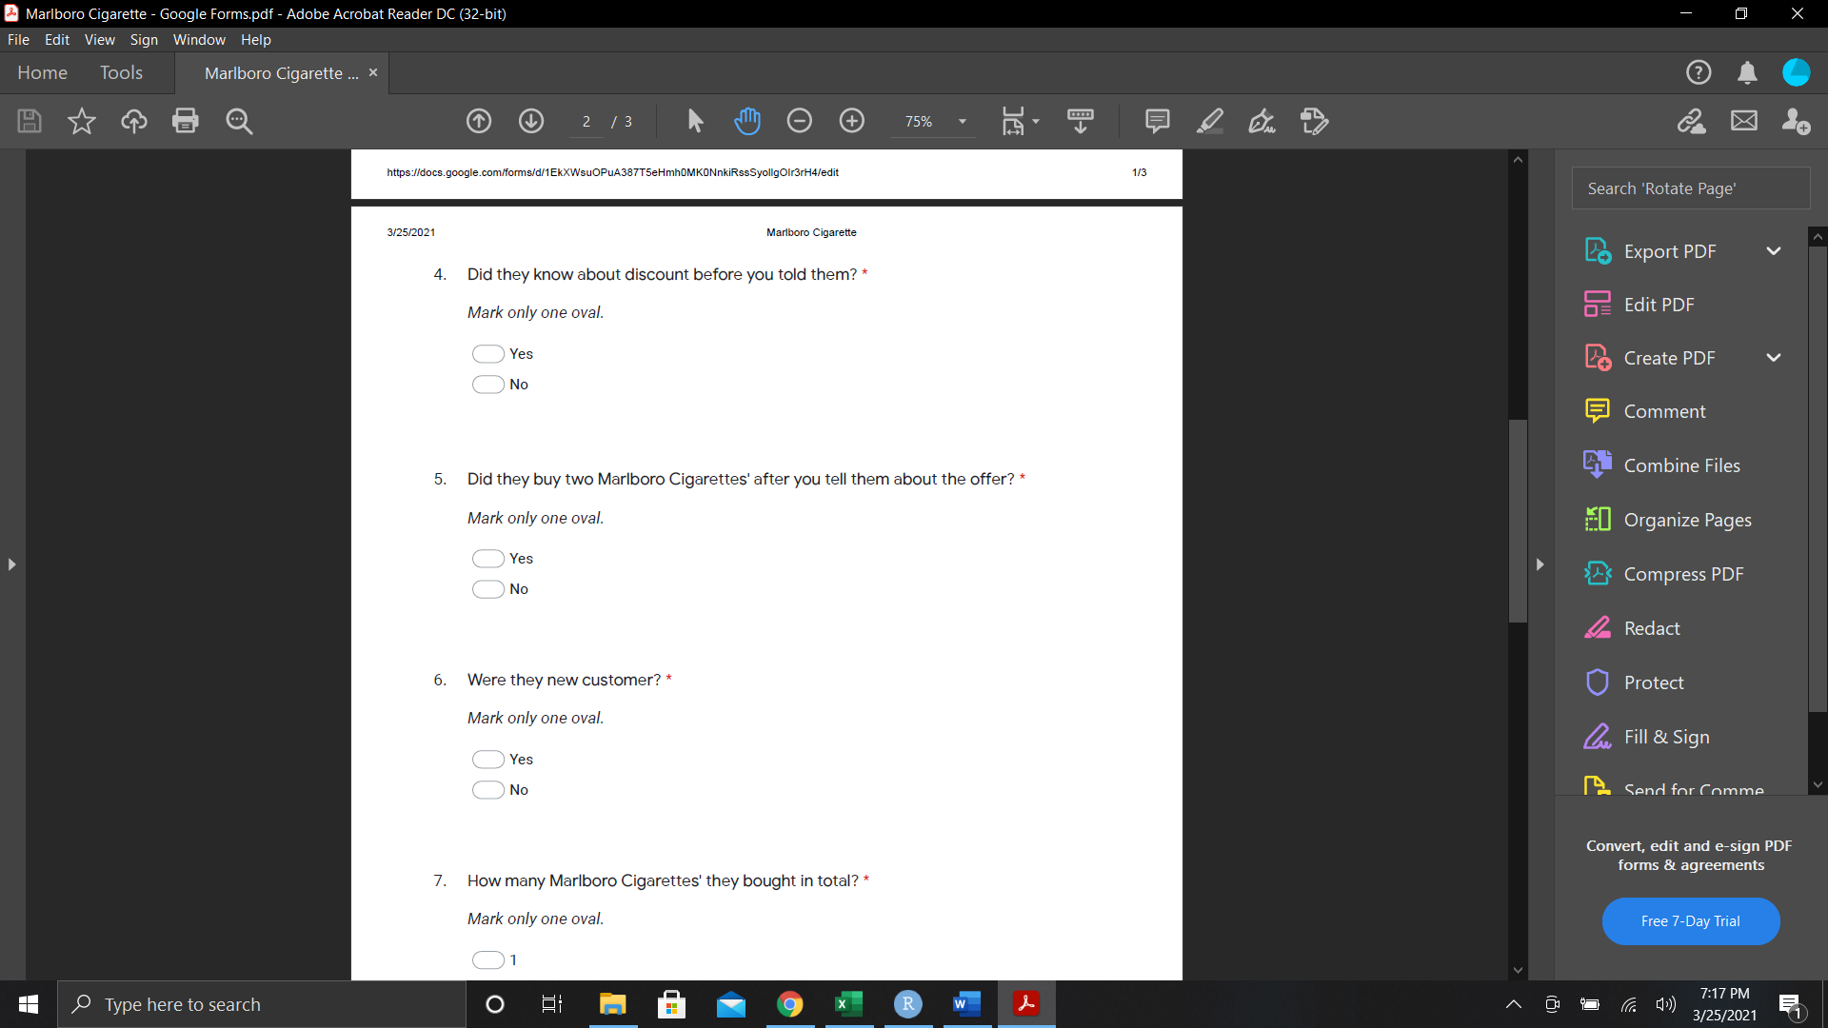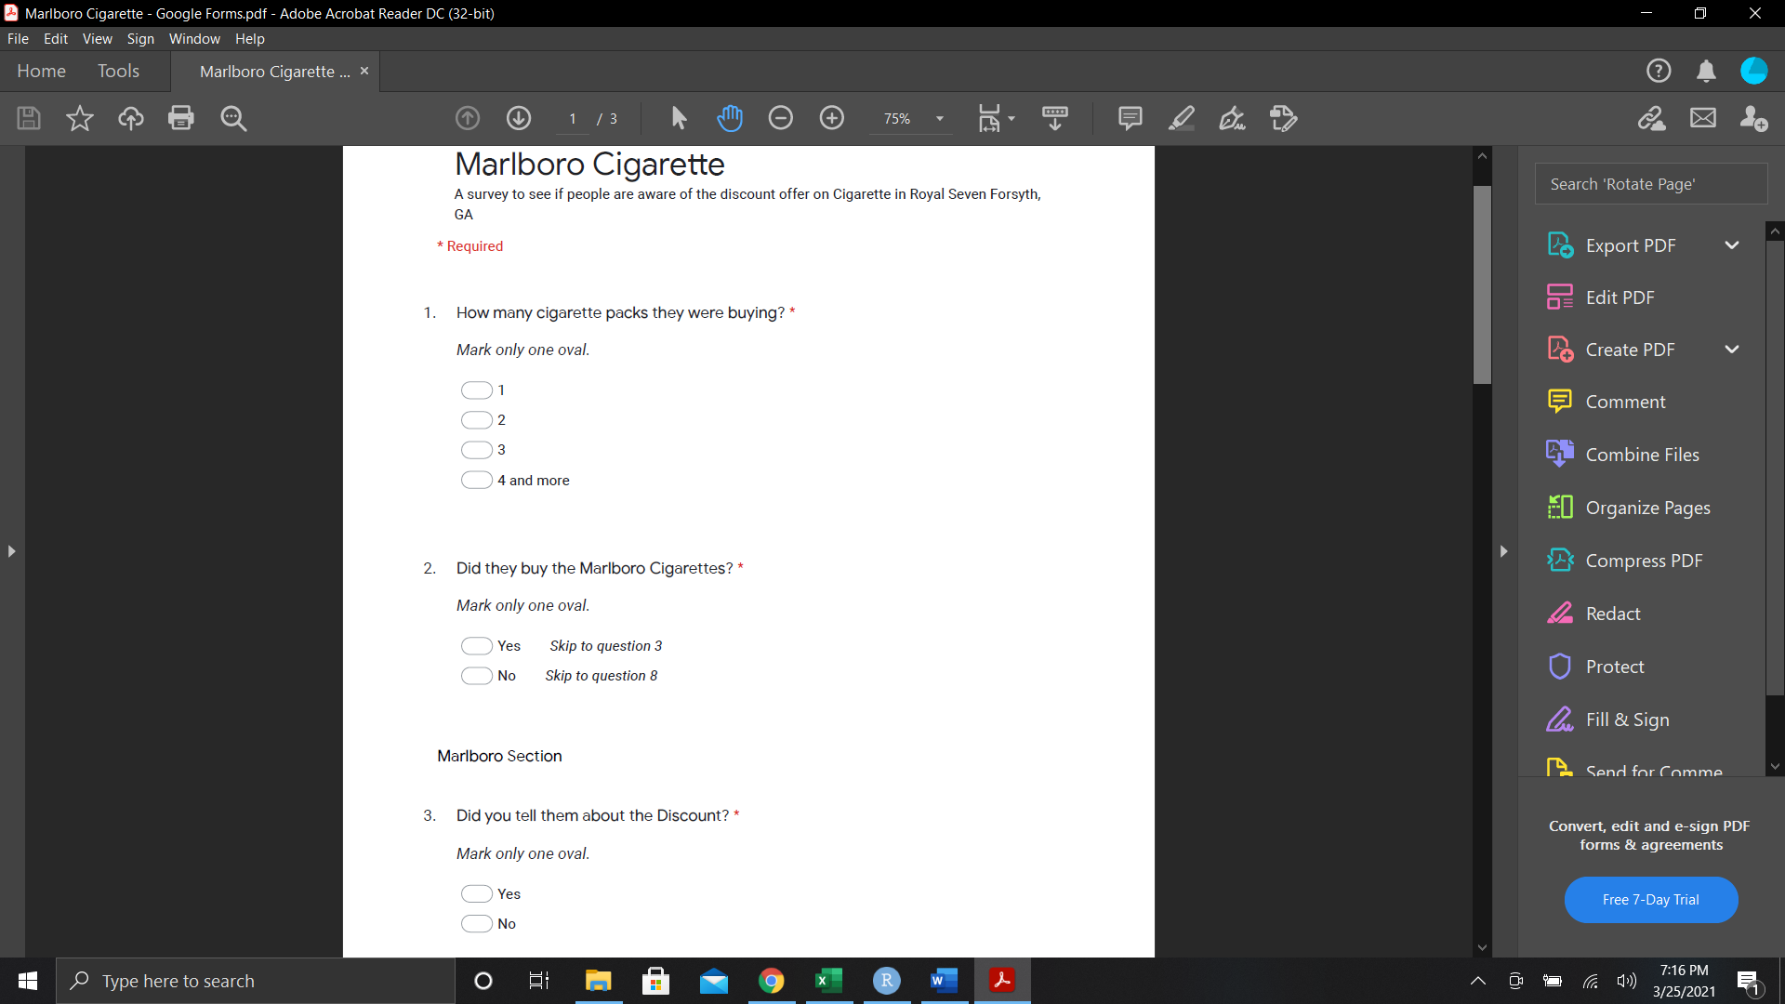

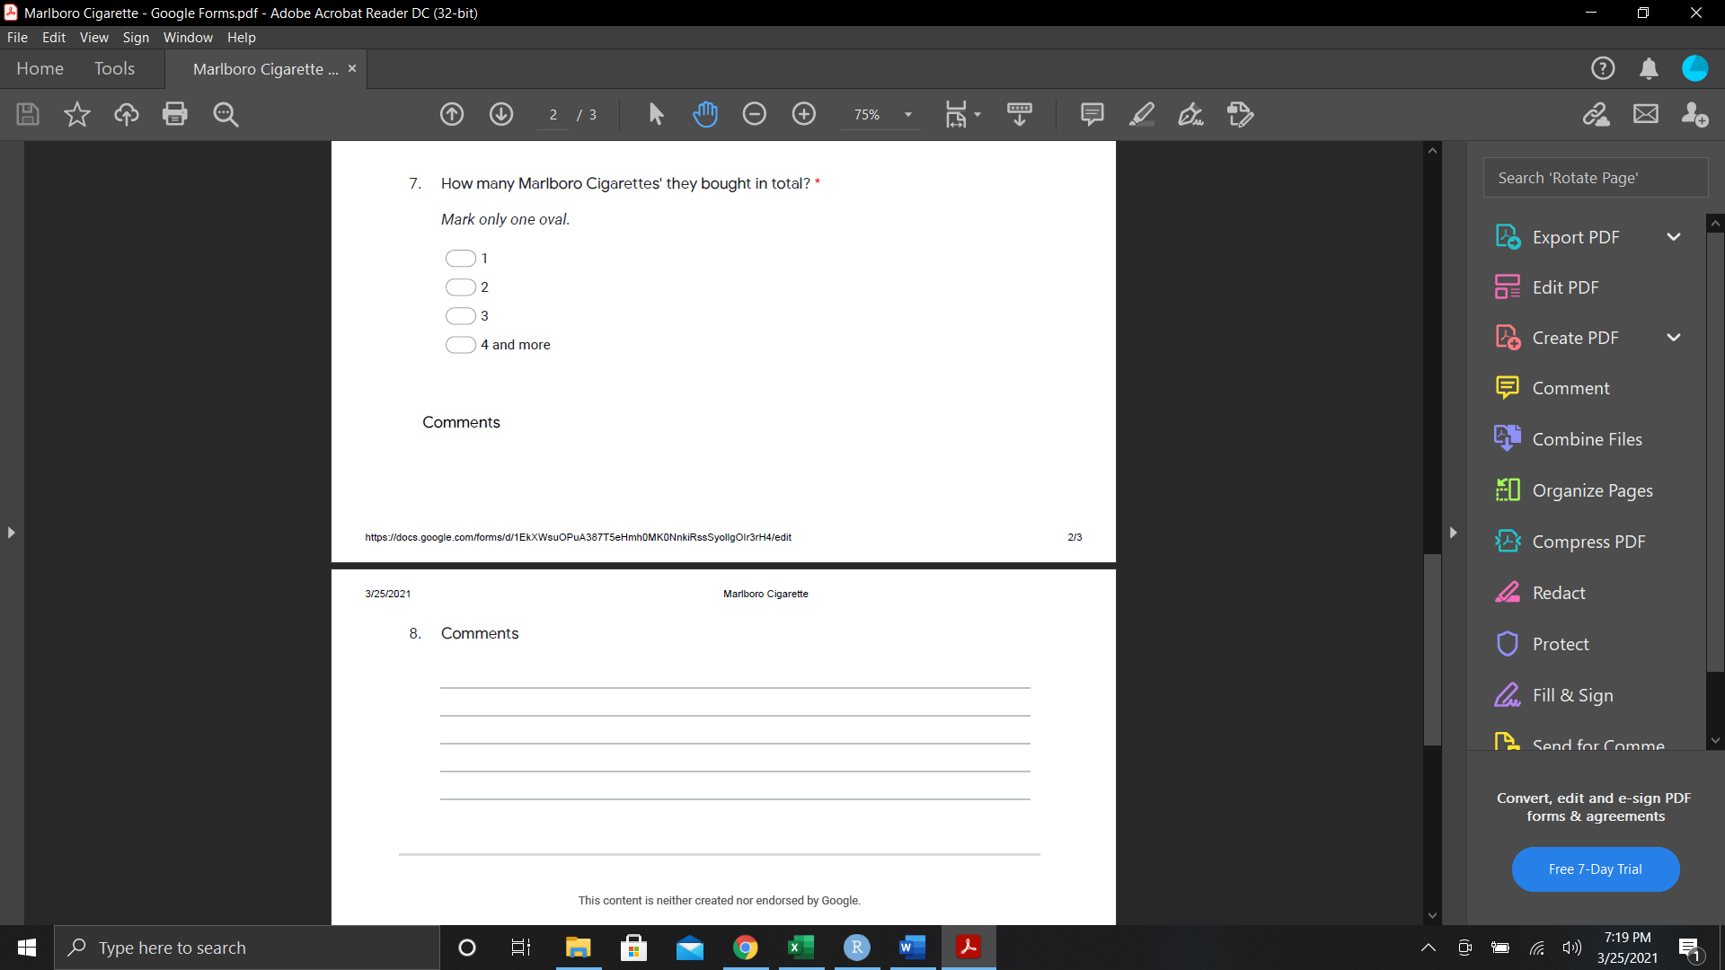

Analysis

The Data I collected for the analysis gives deep insight in the people behavior while buying the cigarettes. Almost 43% of the time, people preferred to buy Marlboro Cigarettes. Since we did not collect the data for the other types of cigarettes. But from the experience and comparatively low cost of Newport cigarettes, I would say that majority of around 57% will be Newport with next cigarettes to be Camel or Pall Mall but we cannot say without any certainty. We also see the trend that around 75% of time people were interested in buying a single cigarette pack. Since this is a gas station on busy highway, I would say that people will be more incline to buy a pack rather than 2 considering they might be on a trip.

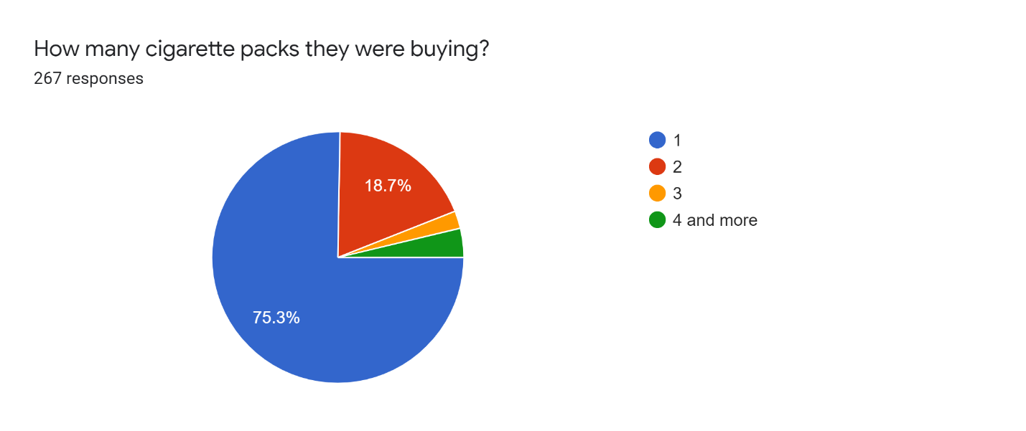

Fig. Shows the number of Cigarettes Packs people are buying for 2 weeks. We have a total of 267 responses

Also, if we do not take Marlboro Cigarettes into consideration, around 81% of people are buying single packs from brands like Newport, Pall Mall etc. This insight could help us deduce more marketing strategies which I will further explain in the suggestion sections.

Now, if we considered people who are buying Marlboro Cigarettes, we deduce whether they know about the discount or not, whether they were new customers and how many packs of cigarettes they finally buy. These results give us some impressive table which provide us with many results.

First, lets look at Customer section. We simply asked whether they are old or new customers. The table that we first looked at was the distribution of new customers in pack buying.

|  |  |  |  |  |
| --- | --- | --- | --- | --- |
|  | Finally Bought | | | |
| Thought of Buying | 1 | 2 | 3 | 4 and more |
| 1 | 20 | 37 | 0 | 0 |
| 2 | 0 | 11 | 0 | 0 |
| 3 | 0 | 0 | 0 | 3 |
| 4 and more | 0 | 0 | 0 | 5 |

As we can see from the table there are new people who did not buy 1 pack after getting to know about the discount. Since the discounts are offered on the even number of products most of them change their decision from talking odd number of cigarettes to even number of cigarettes. Though they are buying more cigarettes this way, they are also saving money on that front. We know that around 65% of people who come in thinking of buying only 1 pack are buying two packs at end. This means that if a person is marketing the discount efficiently, he or she will have more people buying the cigarettes than before. We also see that there is no deviation on people who are already buying 2 or 4 packs and that is because we are not giving anything special if they buy more than 2 or more than 4 for now. People who were buying 3 packs earlier will have 100% according to data that they will get 4 packs or more as they will still get a dollar off from their cigarettes.

The next able shows the distribution of regular customers.

|  |  |  |  |  |
| --- | --- | --- | --- | --- |
|  | Finally Bought | | | |
| Thought of Buying | 1 | 2 | 3 | 4 and more |
| 1 | 12 | 8 | 0 | 0 |
| 2 | 1 | 14 | 0 | 0 |
| 3 | 0 | 1 | 1 | 0 |
| 4 and more | 0 | 0 | 0 | 1 |

In this table we can see that people who are regulars are usually stuck with their decisions and does not deviate much. Occasionally they would end up getting two cigarettes but not many of them are doing that. This deviation is that of 40 % which could be increased if we have more marketing done. We also notice that people are downsizing the number of cigarettes as well. There were couple of them who downsize from 2 to 1 pack and 3 to 2 packs. Their main reasons were because of cost being too high and not having enough money to buy them.

Now if we considered whether we have told them about the discount or not, we get the following table.

First, we will look if we have told them about the discount. This means that we were controlling of whether we told the discount or if they ask for it.

|  |  |  |  |  |
| --- | --- | --- | --- | --- |
|  | Finally Bought | | | |
| Thought of Buying | 1 | 2 | 3 | 4 and more |
| 1 | 30 | 44 | 0 | 0 |
| 2 | 1 | 24 | 0 | 0 |
| 3 | 0 | 0 | 1 | 3 |
| 4 and more | 0 | 0 | 0 | 6 |

This table gives us more detail factors of how cashier can potentially increase the sale of cigarettes depending on how they are interacting with the customer. As you can see from the table 59% of time people are getting 2 packs rather than 2 while 75% of time people are getting 4 packs or more rather than getting 3 packs of cigarettes. We also see that there was a person who did not buy the 2 packs and get down to one. This means that usually people are changing their option if the discount is told.

Finally let us see what happens when we do not tell the discount

|  |  |  |  |  |
| --- | --- | --- | --- | --- |
|  | Finally Bought | | | |
| Thought of Buying | 1 | 2 | 3 | 4 and more |
| 1 | 2 | 1 | 0 | 0 |
| 2 | 0 | 1 | 0 | 0 |
| 3 | 0 | 1 | 0 | 0 |
| 4 and more | 0 | 0 | 0 | 0 |

If we do not tell them about the discount, people are mostly stuck with there option and we only see couple of changes. Since we were told by the manager to talk about the discounts, I was not able to get the other side of data and this data might be subject to change depending on which day we choose to not talk about discount.

Another thing which I did was emotional analysis. This was just a way to see what the general emotion of people was who were buying cigarettes. Here is the result most common emotion that I observed in the people while I was selling the cigarettes.

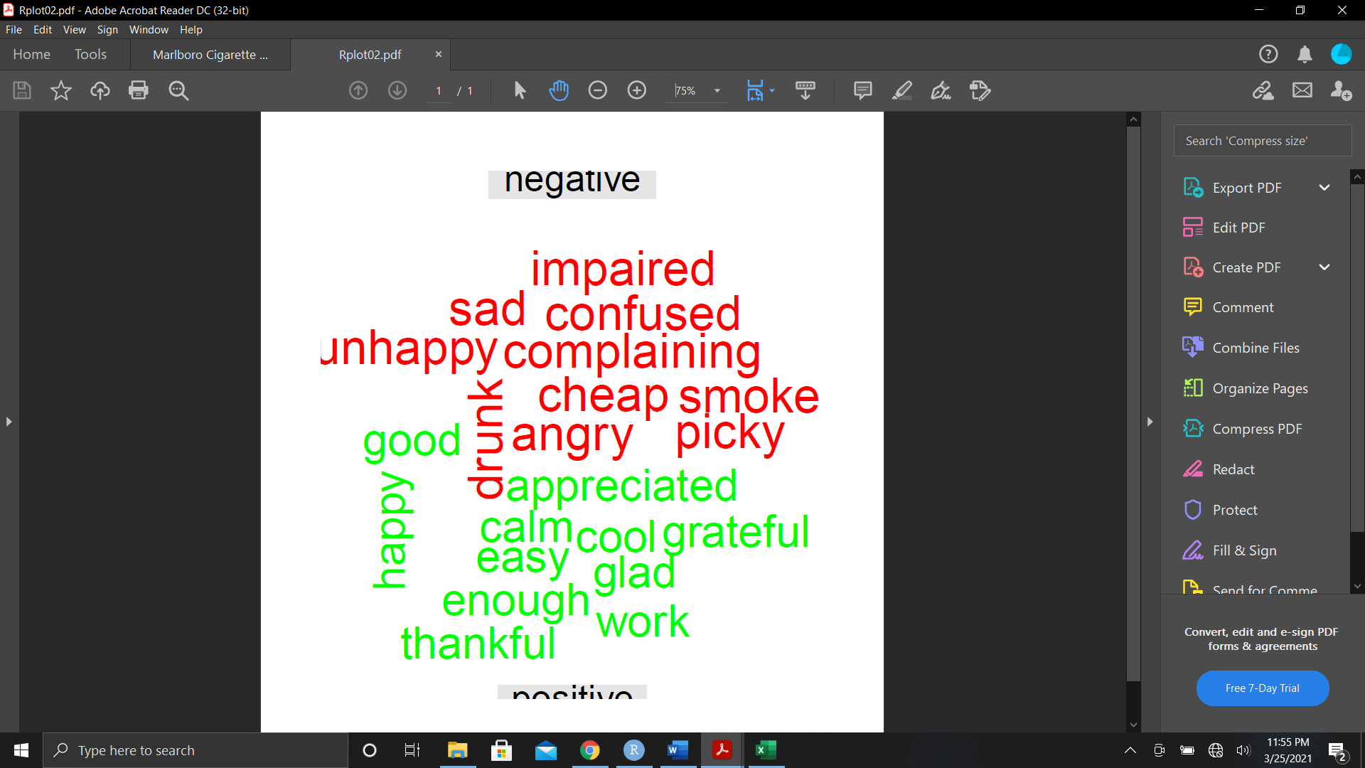

Green represents the positive emotions while the red represents negative emotion. You can see that there was more word in green (just one more) than in red. People who usually come have neutral reaction which is not shown here but these emotions can also help the company in gaining some insights on customers life and in turn help them to make profits. Since there are people who were smoking and were drunk, these people should not be allowed on property. As for people who are sad, we can play a mellow music so that they spirits can be boosted. Same can be said for people who are confused and angry. The proper music and great customer service can help them be less depressing and move them towards neutral position. As for the complaining and picky customers we can add a suggestion box where can get the valuable feedback and help us improve the store services.

I also made a word cloud. This does not give us any insights, but this could be displayed in store as a reminder to owners on which days are going well and which are going bad.

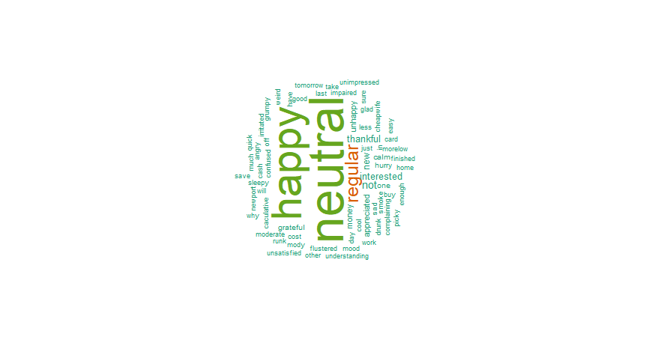

Suggestions

I think that people are different, and everyone have different needs. As an owner, I know we cannot help everyone, but we can generalize the ideas so that we can improve customer service and make profits at the same time.

As we can see from the data about the other Cigarettes, we know that people are buying a lot of Newport’s, Pall Mall and Camel. We can selectively select the cigarettes which will see quicker rather than see the stuff which will take time. This way we can earn money faster and use the space for cigarettes more effectively. As you can see from the image given below, we have 5 slots open right now with no cigarettes. These places can be first to fill. I heard a lot of people asking about the THIS (one of the cigarettes brands) Cigarettes, maybe we can do a trial run for that and make our way up from there. We can also design a survey where people can choose which cigarettes they would like to be in the store. This way we

can get the cigarettes which have the most votes. Another thing which can be done is removing the least selling cigarettes which hardly sell. For example, Darium cigarettes (Not sold during my time as cashier till now). Another thing that can be done is giving certain discounts with popular cigarettes like Newport. Now I am not saying to give them on cigarettes alone, What I have in mind is that to allow people to buy cigarettes along with more items which are more than 20 dollars store can give them 50 cents to a dollar off depending on how much they buy.

As for the Marlboro Cigarettes, we have all the necessary terms but the only thing which is missing is the marketing. When we consider marketing, we have the following promotions that I have seen.

I only see one physical poster which was near the sign and is quite small and could not be seen in night. Though the screens in the store make up for it, it still needs 5 to 10 seconds to get to the discount coupon back by that time the people will only see the screen coincidentally which will be not good for the sales. I purpose to have a physical poster on one of the widows outside of the store like we have for Papa Johns Pizza. We can also ask the cashiers to remind the people when they are buying the cigarettes about the discounts.

Future Work

Like the saying goes, ‘Rome was not built in a day’ in same way, I think this project also have room for improvements. Like I have said before, the data was collected by me during my shift as a cashier there from 3pm to 10 pm with some extra time that I did. Right now, this data is only true for the time being what I have observed. We can get more accurate results if we can get the data from all the shifts. We can also see how cigarettes sales other than Marlboro are distributed and how much they are buying at a time. We can also see how cashier response to whether to tell discount or not effect the sales and how people response to certain time of day and certain day of week while buying cigarettes. These things could surely help us improve the people who are coming in and increase the profits in the store.

Conclusion

Personally, it was more of learning experience for me. But if this project could be of use to the owners, it would be a double win for both of us. This project was just to improve my profile, but it was fun experience for me at end of the day. Also, I would like to thank my co-worker Taylor and Karizma for help me out during these past two weeks in collection of data.